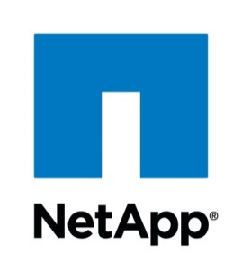

Technical Documentation

Svm Dr - Create New Svm Dr

nov 2018

*Number of pages : 3*

*Version : 1.0.1*

# Document Information

## Revision History

|  |  |  |  |  |
| --- | --- | --- | --- | --- |
| Date | Version | Status | Prepared by | Comments |
| 2018-11-14 | 1.0.1 | Draft | WFA | Initial Draft |
|  |  |  |  |  |
|  |  |  |  |  |
|  |  |  |  |  |

## Document Control

|  |  |  |  |
| --- | --- | --- | --- |
| Role | Name | E-mail | Telephone |
|  |  |  |  |
|  |  |  |  |
|  |  |  |  |

## Approval

|  |  |  |  |
| --- | --- | --- | --- |
| Role | Name | Signature | Sign-off Date |
|  |  |  |  |
|  |  |  |  |
|  |  |  |  |
|  |  |  |  |

## Table of Contents

Document Information 2

Revision History 2

Document Control 2

Approval 2

Table of Contents 3

# Introduction

## Purpose

This document defines the operation of the workflow, input parameters and performed tasks.

## Description

Creates a new SVM Dr relation.  
Creates the new svm, with all its settings and will initialize snapmirrors for all volumes. This workflow assumes that the destination svm will be identical (same vlan's, same ip's, ...)  
  
If the svm is cifs enabled, you will need to provide a temporary IP to join in AD. You also need to point out the cifs lif we can tempory clone to attach that IP. The temp lif will be removed again after join.

## Assumptions

For individuals reading this document please note that the following has been assumed:

* A familiarity with NetApp products and technologies
* WFA configuration and NAS system configuration meets requisites and configuration defined in the documents "Storage Engineering WFA Standards" and "Storage Engineering WFA NAS Provisioning and amendments Standards"

# Workflow Inputs and outputs

## Screenshot

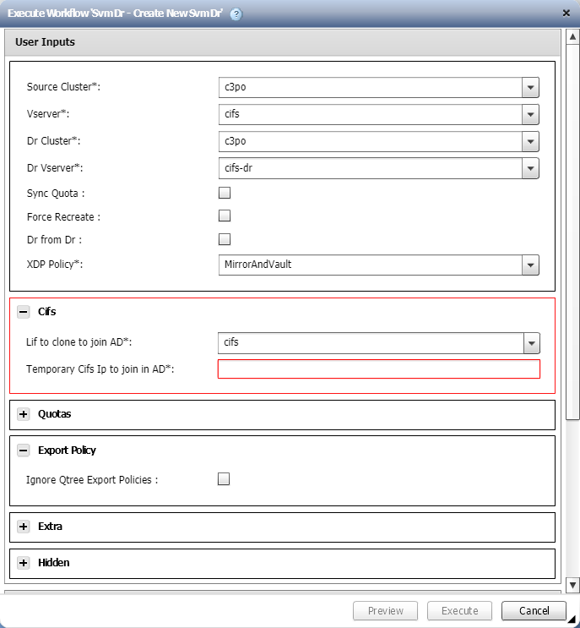

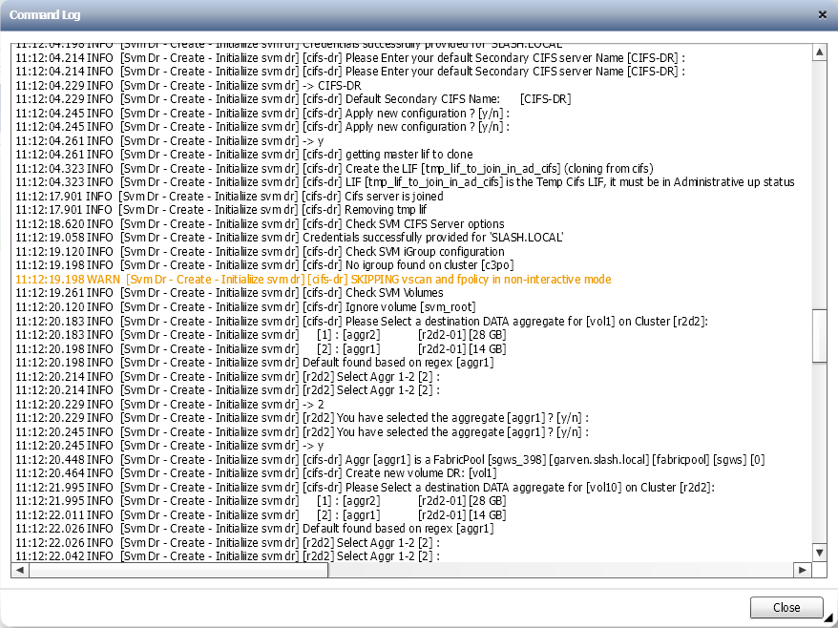

## Workflow inputs

The table below shows the general workflow inputs.

|  |  |  |  |
| --- | --- | --- | --- |
| Name | Type | Description | Notes |
| Source Cluster | Query |  | Mandatory. |
| Vserver | Query |  | Mandatory. |
| Dr Cluster | Query |  | Mandatory. |
| Dr Vserver | Query |  | Mandatory. |
| Sync Quota | Boolean | Enables quota sync. Quota's will be backed up and restored during DR Activate. |  |
| Force Recreate | Boolean |  |  |
| Dr from Dr | Boolean | Enable this if the source is already a DR target |  |
| XDP Policy | Query |  | Mandatory. |
| Lif to clone to join AD | Query |  | Mandatory. Conditional based on 'Cifs Enabled' when the values are: yes. |
| Temporary Cifs Ip to join in AD | String |  | Mandatory. Conditional based on 'Cifs Enabled' when the values are: yes. |
| Ignore Quota Off | Boolean | Ignore quota on volumes where quota is off | Conditional based on 'Sync Quota' when the values are: true. |
| Force Delete Quota | Boolean | Force removal of quota if quota contains errors | Conditional based on 'Sync Quota' when the values are: true. |
| Correct Quota Errors | Boolean | Enable quota correction (only works in some occasions) | Conditional based on 'Sync Quota' when the values are: true. |
| Ignore Qtree Export Policies | Boolean |  |  |
| Debug | Boolean |  |  |
| Cifs Enabled | Query |  | Mandatory. |
| DR Suffix | Query | DR Suffix (see wfa.ini file) | Mandatory. |

## Workflow outputs

None.

# Workflow operation

## Workflow commands

The table below shows the commands used in the workflow.

Not all the commands may run in every execution. There are conditionals that may disable a set of commands if conditions are met.

|  |  |  |
| --- | --- | --- |
| Name | Base command | Description |
| Search or define | Search or define / 1.0.0 | This is an empty command used for search or define step in the designer. |
| Svm Dr - Create Cluster Relation | Svm Dr - Create Cluster Relation / 1.0.0 | Creates & Updates a relationship configuration between 2 vservers |
| Search Cifs lif | Search or define / 1.0.0 | This is an empty command used for search or define step in the designer. |
| Svm Dr - Create / Initialiize svm dr | Svm Dr - Create - Initialiize svm dr / 1.0.1 | Creates and initializes new relationship between 2 vservers This command can be run multiple time  you can provide some of the optional parameters    - A temporary IP to join in AD.  - A lif master template (to clone) to join in AD. (merged with the temp ip)  - A combination of the aggregate options to have smart aggregate selection  - The Node regex, to make smart node selection  Aggregate Resource Selection is in the following order   1) Regular Expression  2) Default Aggregate  3) Aggregate with most available space  The AggrMatchRegex and NodeMatchRegex work like this :  - Your regex is first applied to the primary resource  - Then all "regex groups" are replace by wildcards   Examples :  - 1 on 1 match : ".*" => (src = aggr1 ; dst = aggr1)   - string replace : "ep(.*)snas[0-9]*_aggr[0-9]*" => (src = ep*snas54_aggr1 ; dst = ep*snas54_aggr1)  - node number match : "(.*)-[0-9]{2}" => (src = *-03 ; dst = *-03)  #version control 1.0.0 Initial version 1.0.1 Add ldap credentials |

# Apendix

## Workflow versions

|  |  |
| --- | --- |
| Version | Comments |
| 1.0.0 | Initial version |
| 1.0.1 | Drop config file requirement |